Final Report

Introduction to Database

1. **Overview of project**
2. Target

: SKKU library: https://lib.skku.edu/#/

1. Purpose

: This project is to provide a online service for the library users.

1. Objective

I tried to create library system website. I refer to a various online library website. To stick to the basics, I would like to implement basic functions for an online library service

1. Functionality
2. Join to be added in the user list
3. Login and logout by user id and password
4. Show information of the logged in user
5. Search books by keywords
6. Show books in the list
7. Add books to the book list
8. Add reservation to the book reservation list.
9. Add and show book reviews
10. Reserve study room
11. **ER diagram**

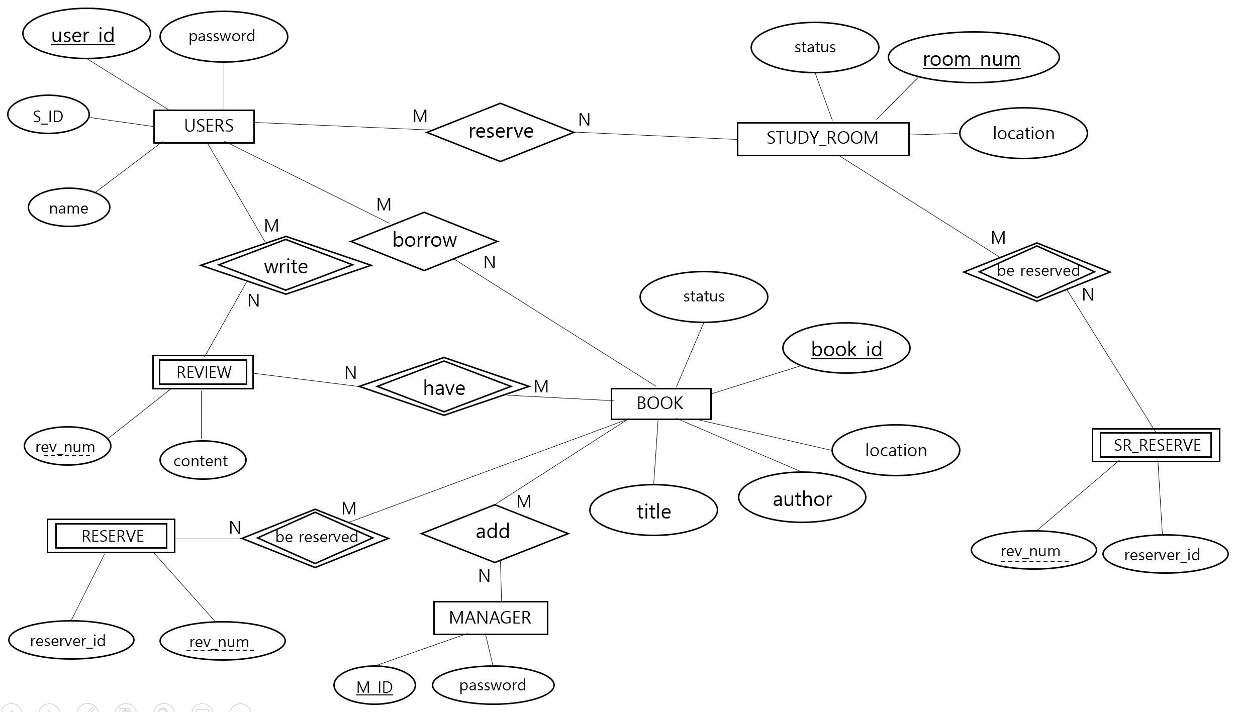

Explanation:

1. USERS entity stores information of each user. Each tuple in the entity is added by signing up in the web page. User who want to join the library system fill out the user information form and submit it. Then the information is added to the USERS table. Key is user_id. user_id and password are necessary to log in the system.

Many users can borrow many book and reserve many study rooms and write many review, so all the relationships between those entities and users are M:N.

1. BOOK entity contains book_id as a key, title, author, location, and status as attributes. location represents the floor where the book is located and status represents the book condition whether it is available to use or unavailable, so status data type is Boolean. Status=1 means available, and 0 means unavailable.

Many books can have lots of reviews and reservation, so relationships between book and review, reserve is M:N.

1. Manager who is an administrator of the system can add the book in the book relation. MANAGER contains m_id as a key and password to log in as an administrator. Many managers can add many books in the list, so they are in M:N relationship.
2. REVIEW is a weak entity because they can exist only when user and book exist. Therefore, book_id and user_id is referred to this table as a foreign key. It has rev_num as a partial key because it can distinguish each tuple. It also has content which represents description of review.
3. STUDY ROOM contains room_num as a key, location, and status. Location and status represent information same as book attributes. Many study rooms can have many reservation, so both have M:N relationship.
4. SR_RESERVE contains reservations of study rooms. It has rev_num as a partial key and reserver_id. It is a weak entity because it cannot exist without study room. It refers to room_num from study room entity.
5. **Relational Model**

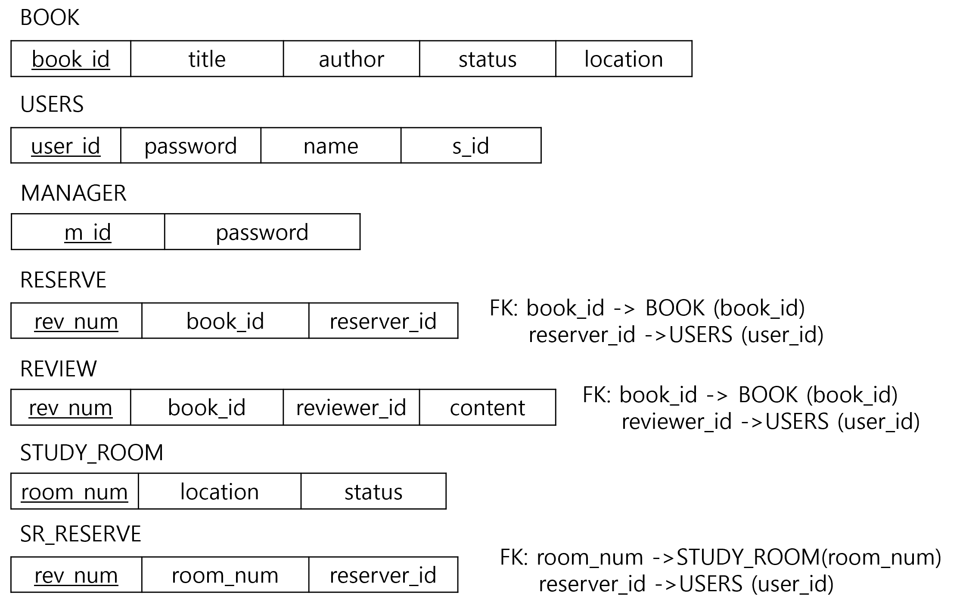

Explanation:

1. BOOK relation has book_id as a primary key because it can discriminate each tuple. All the attributes include an information of the books in the database. Status represent the condition of the book whether the book is available(1/true) or unavailable(0/false) to borrow. title and author are used as keyword when users search for the specific book.
2. USERS relation contains user data who can use the library service. Tuples can be inserted by entering the information by users when they join the system. Every user has own user_id, so it should be the primary key. user_id is referred lots of relations. User_id and password are used when users log in the system.
3. MANAGER relation is for administrators of this system. m_id is the primary key.
4. RESERVE relation consists of rev_num as a primary key and book_id and reserver_id as attributes. book_id and reserver_id is a foreign key. book_id is referred to book_id which is a primary key of BOOK relation and reserve_id is referred to user_id which is a primary key of USERS relation.
5. REVIEW relation stores review of books written by users. rev_num, which is a primary key, is set to auto-increment to be ordered automatically as review is written. Book_is, which is referred to book_id from BOOK, reviewer_id, referred to user_id from USERS, and content is inserted by users. Users can fill out the review form and reflect the data to databases.
6. STUDY_ROOM relation contains room_num as a primary key, location and status. Location represents the number of floor that the is located. Status represents the condition of the study room whether it is available or unavailable to user. Status=1 means available and 0 means unavailable.
7. SR_RESERVE contains an information of study room reservation. rev_num is a primary key and is set to auto-increment to be ordered automatically when a new reservation is created. The relation also has room_num and reserver_id as a attribute. Room_num is referred to room_num from STUDY_ROOM and reserver_id is referred to user_id from USERS.
8. **Implementation and Results**

The first page of the system:

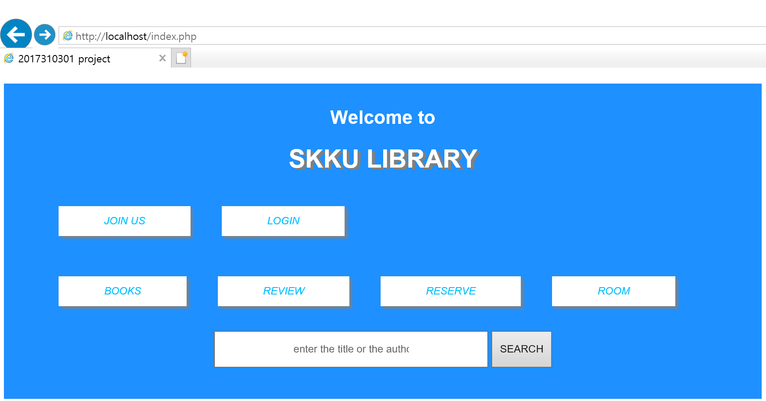

1. Join to be added in the user list

This is the picture of when click ‘join us’ button on the menu and after fill out the form and click ‘submit’ button. After close the alert message with ‘Complete’, written data is inserted to the user table and ‘Go to login’ button appears. The button is linked to login page.

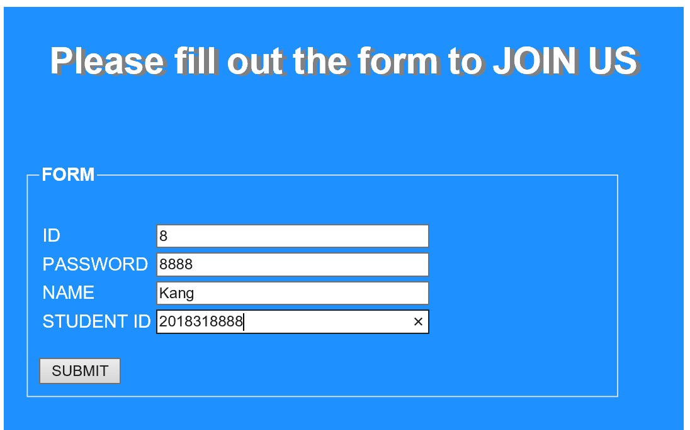 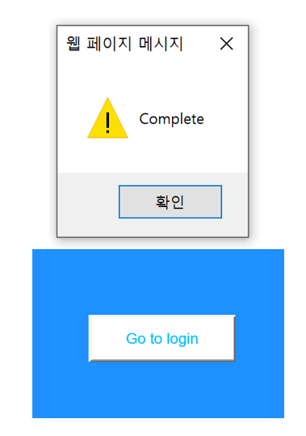

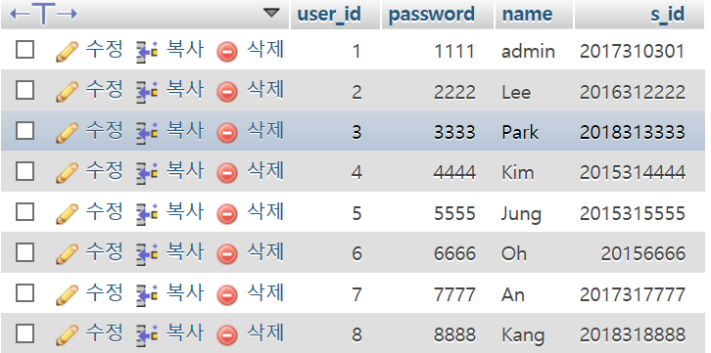

1. Login and logout by user id and password

A user in the users table can login with user id and password they set when signing up. After clicking LOGIN button, buttons of the menu are changed to LOGOUT from JOIN US and LOGIN. It goes back to the first page by clicking LOGOUT button.

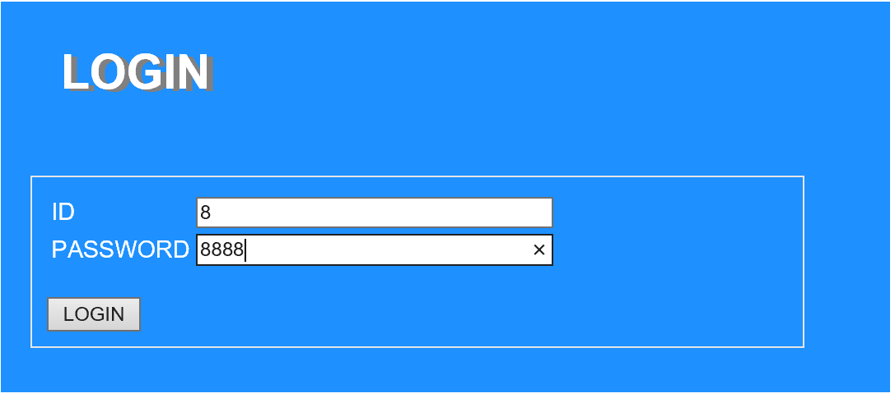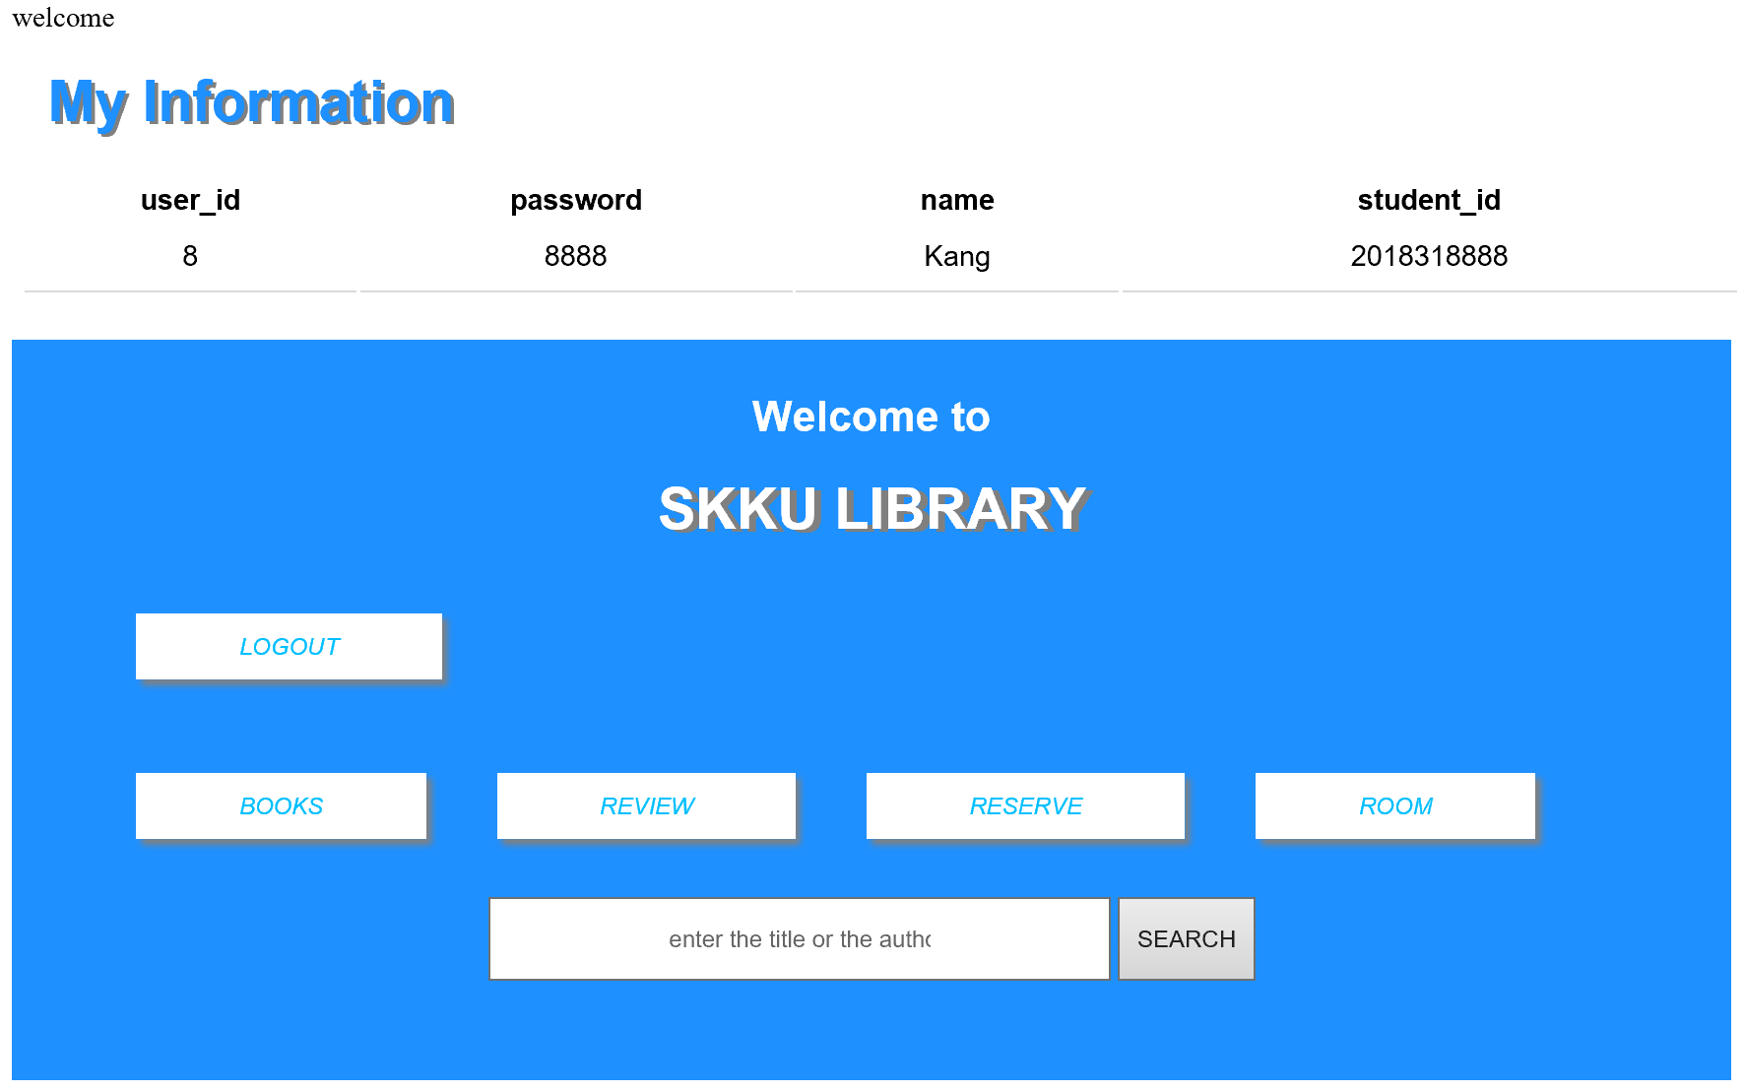

1. Show information of the logged in user

The logged in user can see this information page that include their information.



1. Show books in the list

This is the picture of when clicking BOOK button on the menu. This page shows books in the book database. Users can go back to a previous page through ‘back’ button.

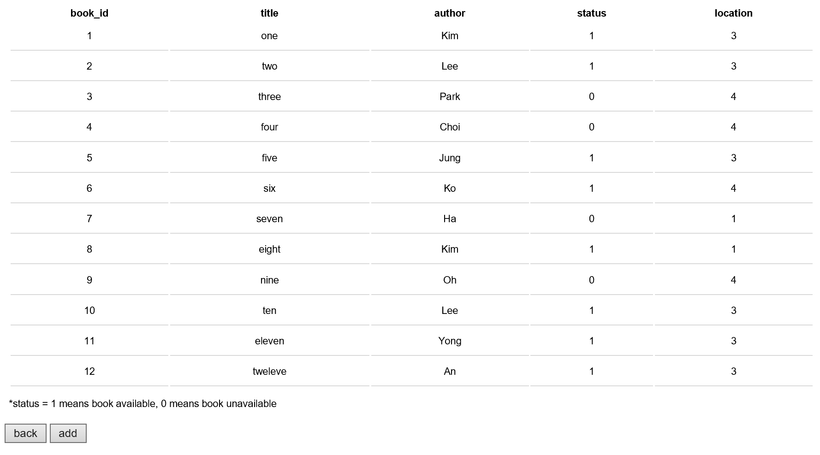 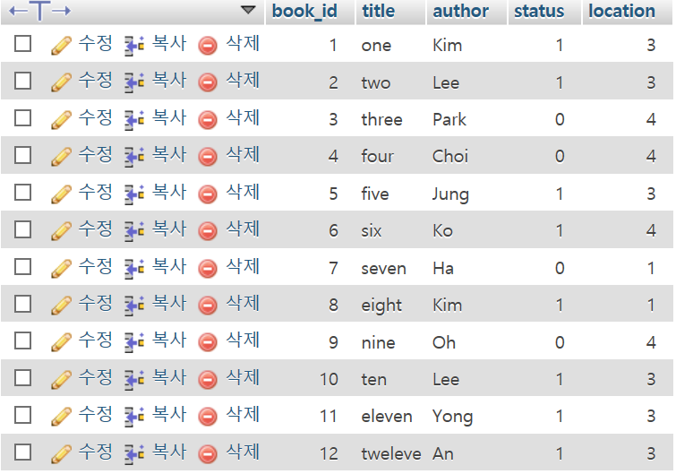 ◀ book database

1. Add books to the book list

Administrator can add the books in the list in this page that appears when clicking ‘add’ button below the book list page. After filling out the form and clicking ADD button, the book is added to the list and database and also showed on the list below.

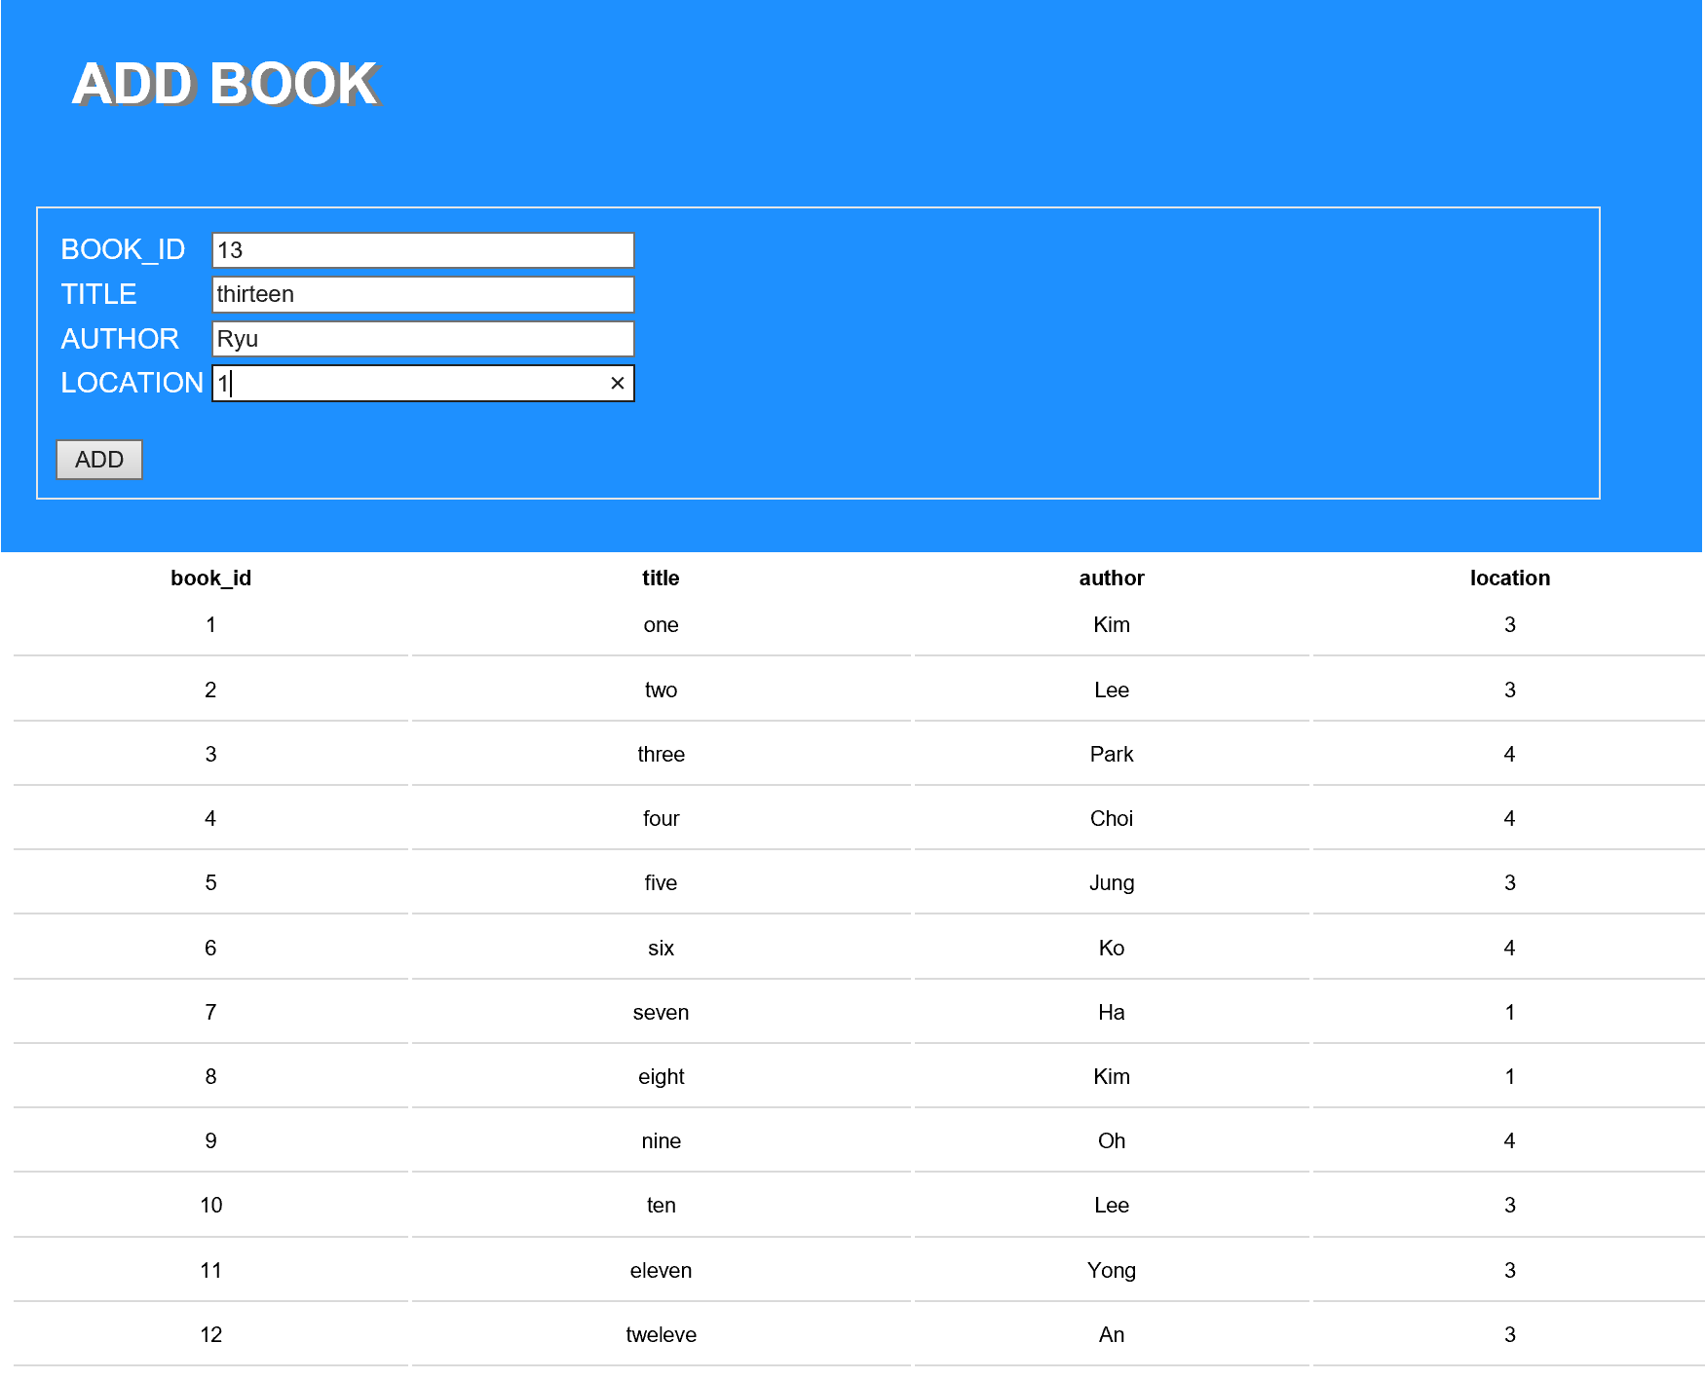

Book list and book database after adding the book ▼



1. Search books by keywords

Users can search book by keywords. Keywords are title and author of the book.



Result of the search with keyword like above ▼



1. Add reservation to the book reservation list

This page appears when clicking RESERVE button on the menu. Users can make a reservation by adding requests in the reservation list. Users can go back to the first page by clicking ‘back’ button.

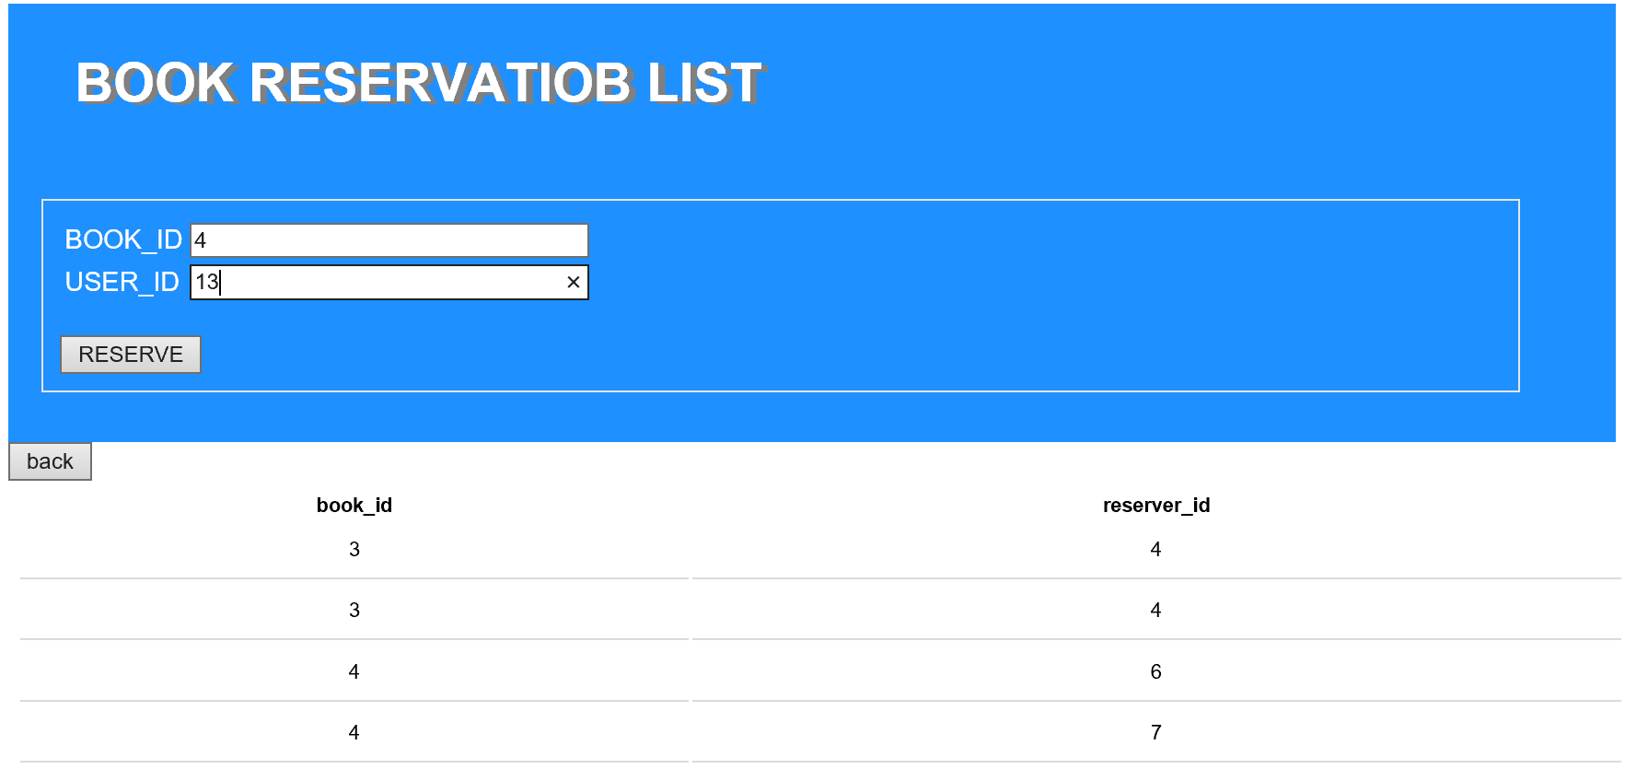

After click RESERVE button ▼



Database of book reservations ▼ rev_num is set to auto_increment

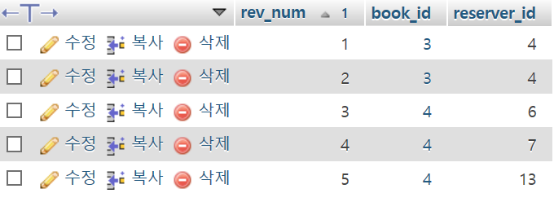

1. Write and show book reviews

This is a page that appears when clicking REVIEW button on the menu. Users can register book reviews by filling out the form and clicking SUBMIT button. Then the content is added to the review list below and review database. Users can go back to the first page by clicking ‘back’ button.

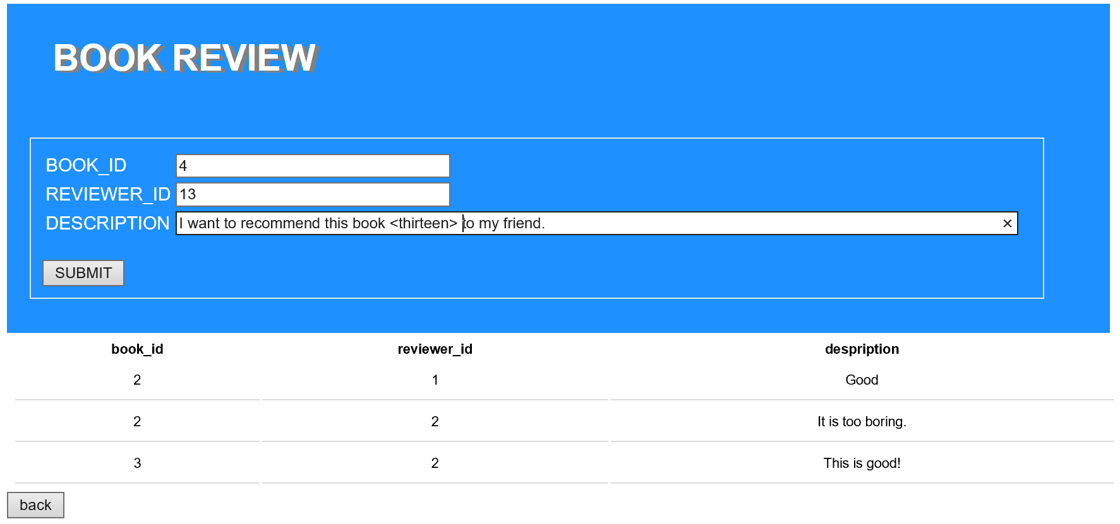

Result of review list and database after submitting the review ▼





1. Reserve study room

When click ROOM button on the menu, this page appears.

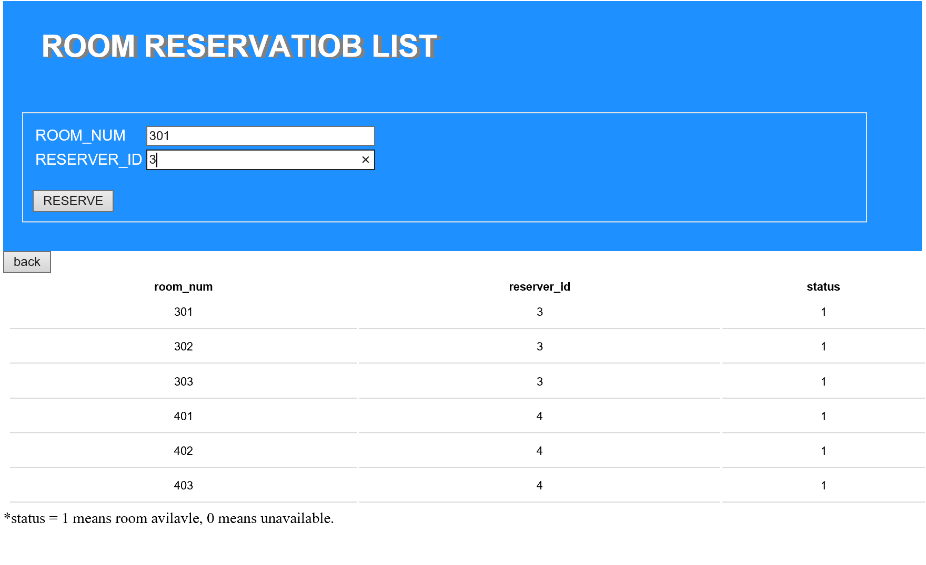

This result appears after filling out the form and clicking RESERVE buttom. This show the list of room reservation that people requested. ▼



▼ Study room reservation database after reserving. Rev_num is set to auto increment.

